Exercise 13
- Which command displays the MySQL version?
Answer: SELECT VERSION();
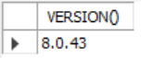

- Use the SELECT command to evaluate 4 x 4 x 4 and name the column Cube of 4.
Answer: SELECT 4 * 4 * 4 AS 'Cube of 4';
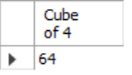

- Display your name with SELECT.
Answer: SELECT 'Jasper' AS MyName;
